Student  Full Name: samuel alicerces catanha | Student  Number: 216013526
Subject:  ADP470S Advanced Development Practice | Test Date:  21 June 2021 | Duration:  3 Hours

Test 2
Faculty of Informatics & Design
Course:
BTech in Information Technology
Question | Student Mark | Max. Score
1 |  | 20
2 |  | 20
3 |  | 20
4 |  | 20
5 |  | 20
6 |  | 20
 |  | 100

Subject Coordinator:
Mr T. Makhurane
Lecturers / Examiners:
Mr T. Makhurane
Moderator:
Internal: Prof E. Ruhode
Special instructions:
Answer ANY 5 questions
Requirements:
Students must not share their anwers with each other. Instances of copying will be taken very seriously.
Provide an original response to each question not a verbatim code excerpt from a source.

%

Question 1
1.1 | Compare and contrast the insertion sort and selection sort algorithms  Describe each algorithm in detail (pseudocode or actual code extracts) will be useful as well as an explanation of how each algorithm works.  A: The main difference between insertion sort and selection sort is that, in the insertion sort the elements are sorted by swapping one element at a time with a partially sorted array, while in the selection sort the elements are sorted by selecting the smallest element and swap it with the correct element location.  For example in the insertion sort the steps are as follow:  - The array is traversed from array[1] to array[n].  - It will compare the key value to its predecessor  - If the key values is smaller than its predecessor it will compare it to all the other elements and then move the greater elements one position up ([n+1]) to make space for the swapped element  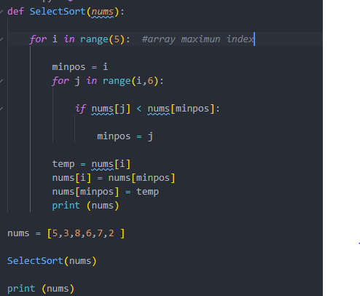  In the selection sort the steps are as follow:  - Iterate through the array[n] and checks for the smallest element  - Find smallest element in the array[n] and place it to the beginning (array[0])  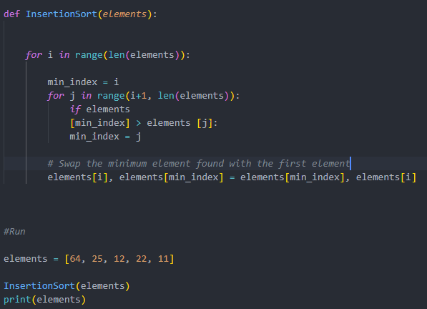 | [10]
 | Explain the performance of both of these algorithms in terms of:
1. | Best case.  The insertion sort algorithm is O(n) in its best time complexity and the selection sort is O(n^2) | [3]
2. | Average case.  The insertion sort algorithm and the selection sort algorithm are both O(n^2) in their average time complexity. | [3]
3. | Worst case. | [4]
 | The insertion sort algorithm and the selection sort algorithm are both O(n^2) in their worst time complexity
Question 2
It is possible to implement a method to evaluate the factorial of a number using an iterative method or using a recursive method

$$n!=\left\{\begin{aligned}1, &n=1 ∨n=0 \\ n\left(n-1\right)!, &n≥2\end{aligned}\right.$$

2.1 | Implement a recursive method for factorial | [5]
2.2 | Implement an iterative method for factorial  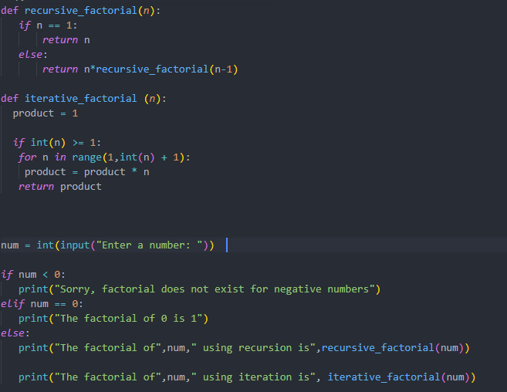 | [5]
2.3 | Using the Big-O notation, compare the performance of these algorithms from a viewpoint of time utilisation and space utilisation. Which one is preferable in the real world?  A: The time complexity of the algorithm using the recursive approach is O(n), because there is no extra space or time taken during the recursion’  The time complexity of the algorithm using the iterative approach is also O(n) but in the real world I would rather use the recursive approach as it is straight forward and call the recursive function only once in each iteration | [10]
Question 3
3.1 | A binary search tree can be implemented using either a static array as a basis or a linked structure as a basis. Explain how the static approach works using code excerpts for insert and traversal operations. 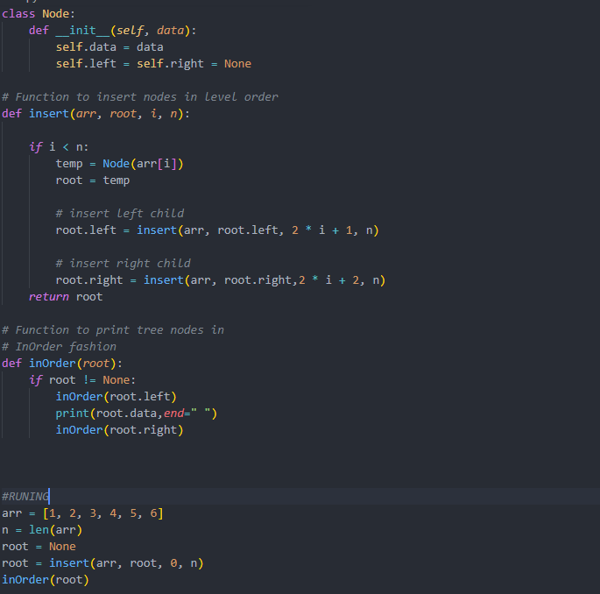  Explain the performance of the insert operation using Big-O notation.  A: It checks the element to be inserted, then traverses the tree and inserts either in the right or left child, and its worst case scenario is O(log₂n). | [15]  [5]
3.
Question 4
4.1 | Implement a stack application using a linked representation. The stack should stack a class called Fruit, where each fruit instance contains the following attributes: fruit_id, name, unit_price and volume_sold.  Demonstrate how 4 fruit objects can be pushed onto a stack and then have their printed as they are successively popped from the stack. Implement the following operations: push, pop, isEmpty, and peek. This must be implemented in an OO language.  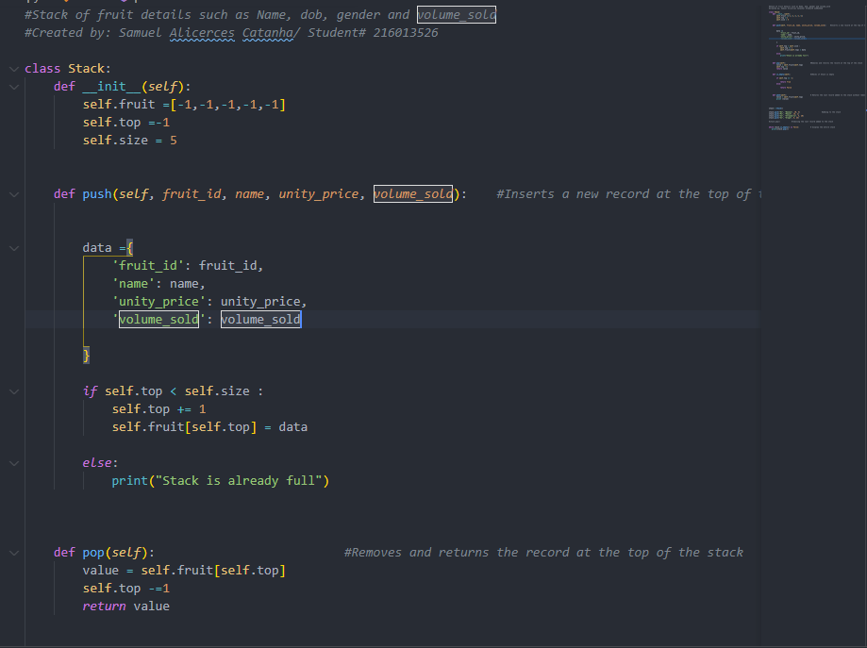 | [10]
 | 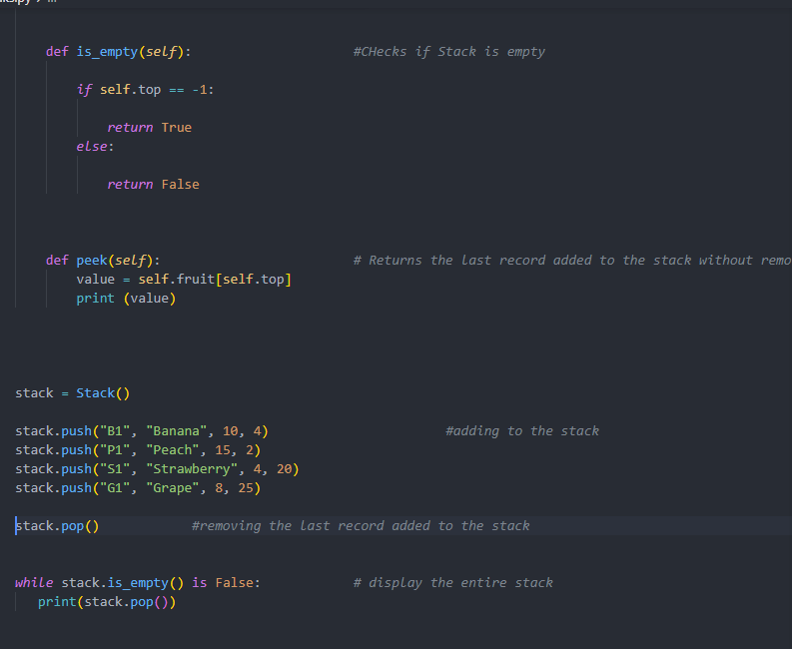
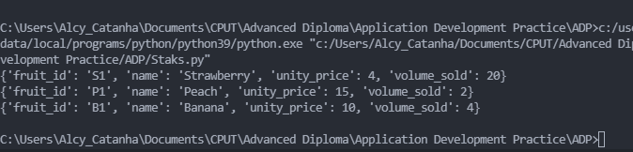
Question 5 [20]
5.1 | Implement a queue using a circular queue representation (circular buffer). Each element in the queue should represent a mouse action such as a click or a double click event. The instance variables should include the following: event_id, event_time, event_type. This must be implemented in an OO language.  The code should implement a running part in which 5 queue events are enqueued (added to the queue) and then later dequeued, to demonstrate that the application works. The following operations should be included:  Enqueue, dequeue, isEmpty, isFull. This must be implemented in an OO language.  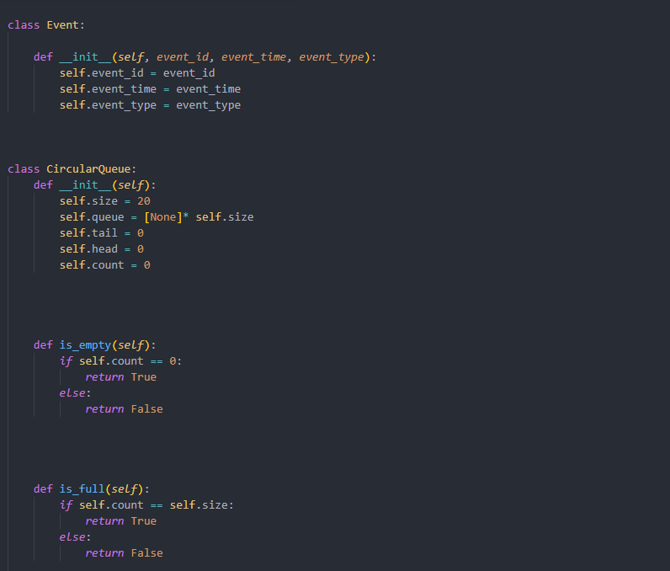 | [20]
 | 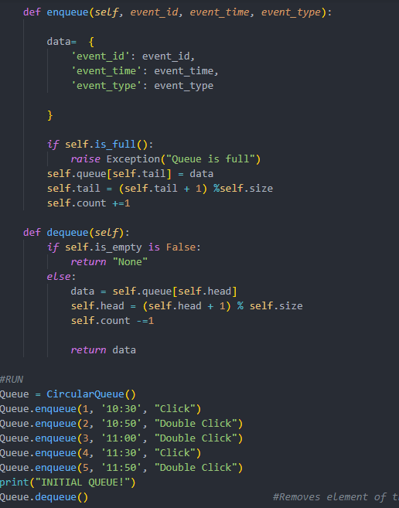
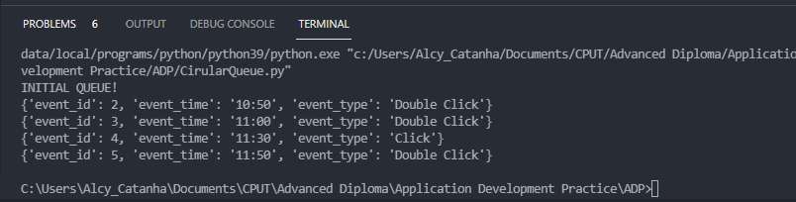

Question 6 [20]
6.1 | Explain the workings of a binary search tree using a linked arrangement which includes a representation of the following operations: Find, Insert, Delete, isEmpty preorder, inorder, postorder. This can be by way of code in an OO language or pseudocode.  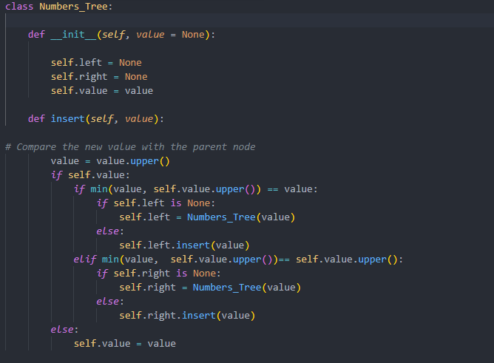 | [10]
6.2 | Draw a diagram of a binary search tree to show how inserting the following values into a tree would work. Insert {10, 5, 15, 16, 17, 18, 19, 20}. | [4]
6.3 | Draw a second diagram to show how inserting the following values into an AVL tree would work. Insert {10, 5, 15, 16, 17, 18, 19, 20}. | [6]

